

**Official Site Metadata Information**

**Lockheed Martin Ground System (LMG6)**

**Indiana University Perdue University Indianapolis (IUPUI) University Courtyard**

**Indianapolis, IN**

**Prepared by**

**Sterling Field Support Center**

**Created June 13, 2014**

**U.S. DEPARTMENT OF COMMERCE**

**National Oceanic and Atmospheric Administration**

**National Weather Service/Office of Operational Systems**

**Field Systems Operations Center/Observing Systems Branch**

|  |
| --- |
| **SITE SPECIFIC DATA FOR: IUPUI University Courtyard Indianapolis, IN** |
| **Date(s) Recorded: 06/09/14** |
| **Survey Team: D. Brewer, D. Fischer** |

|  |  |
| --- | --- |
| Station Name | IUPUI University Courtyard |
| Station Latitude (dd:mm:ss.sssss) | 39:46:25.095 N |
| Station Longitude (ddd:mm:ss.sssss) | 86:10:27.252 W |
| Station Elevation (MSL) | 215.20 m |
| WMO No | NA |
| WMO Region | NA |
| Station ID | NA |
| Time Zone | Eastern |
| WBAN | NA |
| WSFO ID | NA |
| Surface Observation Equipment Type | Fluke 971 (Temp and RH), Kestrel 3500 (Wind Speed), Paroscientific PDB (Pressure) |

|  |  |
| --- | --- |
| **Resident Site Specific Data:**  **Position information was determined using LMG-6 GPS Data Averaged over 2.5 hours** | |
| **Site Commentary** | |
| RSOIS Latitude (dd:mm:ss.sssss) | 39:46:25.095 N |
| RSOIS Longitude (ddd:mm:ss.sssss) | 86:10:27.252 W |
| RSOIS Elevation (MSL) | 215.20 m |
| Surface Observation Equipment Type | Fluke 971, Kestrel 3500, Paroscientific PDB |
| Distance from Release Point (m) | <1m |
| Surface Observation Equipment Bearing (Deg) | NA |
| **Temperature Sensor** | |
| Elevation (AGL) | Handheld |
| Orientation (Bearing) | NA |
| Manufacturer | Fluke |
| Model | 971 |
| Type | Thermistor |
| Calibration Date |  |
| **Relative Humidity Sensor** | |
| Elevation (AGL) | Handheld |
| Orientation (Bearing) | NA |
| Manufacturer | Fluke |
| Model | 971 |
| Type | Capacitive Thin Film |
| Calibration Date |  |
| **Wind Sensor** | |
| Elevation (AGL) | Handheld |
| Orientation (Bearing) | NA |
| Manufacturer | Kestrel |
| Model | 3500 |
| Type | Handheld Propeller |
| Calibration Date |  |
| **Barometer** | |
| Elevation (MSL) | 215.20 m |
| Elevation (AGL) | <0.5 m |
| Orientation (Bearing) | N/A |
| Manufacturer | Paroscientific Inc. |
| Model | 760-16B |
| Type | Portable Pressure Standard |
| Calibration Date | 9/4/13 |

|  |  |
| --- | --- |
| **Resident Site Specific Data: LMG6 Receiver and Antenna’s**  **Position information was determined using a Trimble GPS receiver model 5700. Estimated position error less than** | |
| **Site Commentary** | |
| Base Pressure (hPa) |  |
| Release Point Latitude (dd:mm:ss.sssss) | 39:46:25.095 N |
| Release Point Longitude (ddd:mm:ss.sssss) | 86:10:27.252 W |
| Release Point Elevation (MSL) | 215.20 m |
| Release Point Pressure Correction (hPa) | None |
| Basestation GPS Elevation (WGS84) | NA |
| Basestation GPS Elevation (MSL) | NA |
| Basestation GPS Latitude (N+/S- ddmmss.fffff) | NA |
| Basestation GPS Longitude (E+/W- dddmmss.fffff) | NA |
| LMG6 Elevation (MSL) | 215.20 m |
| LMG6 Latitude (N+/S- ddd:mm:ss.sssss) | 39:46:25.095 N |
| LMG6 Longitude (E+/W- ddd:mm:ss.sssss) | 86:10:27.252 W |
| Radiosonde Type | LMS6 |
| Ground Receiving System | LMG6 |
| Ground Receiving System Serial Number | 134601 |
| Radiosonde Tracking Method | GPS |
| Barometer Height (MSL) |  |
| Balloon Shelter Type | 10’ U-Haul Truck |
| Balloon Gas | Helium |
| Operating Frequencies (MHz) | 403 MHz |
| Rooftop Release | No |
| WMO Header (FZL) | NA |
| WMO Header (MAN) | NA |
| WMO Header (SGL) | NA |
| WMO Header (ABV) | NA |

|  |  |
| --- | --- |
| **Win9000 Computer Site Specific Data** | |
| IP Address | NA |
| Computer Name | NA |
| Default Gateway | NA |
| Subnet Mask | NA |
| Preferred DNS Server | NA |
| Alternate DNS Server | NA |

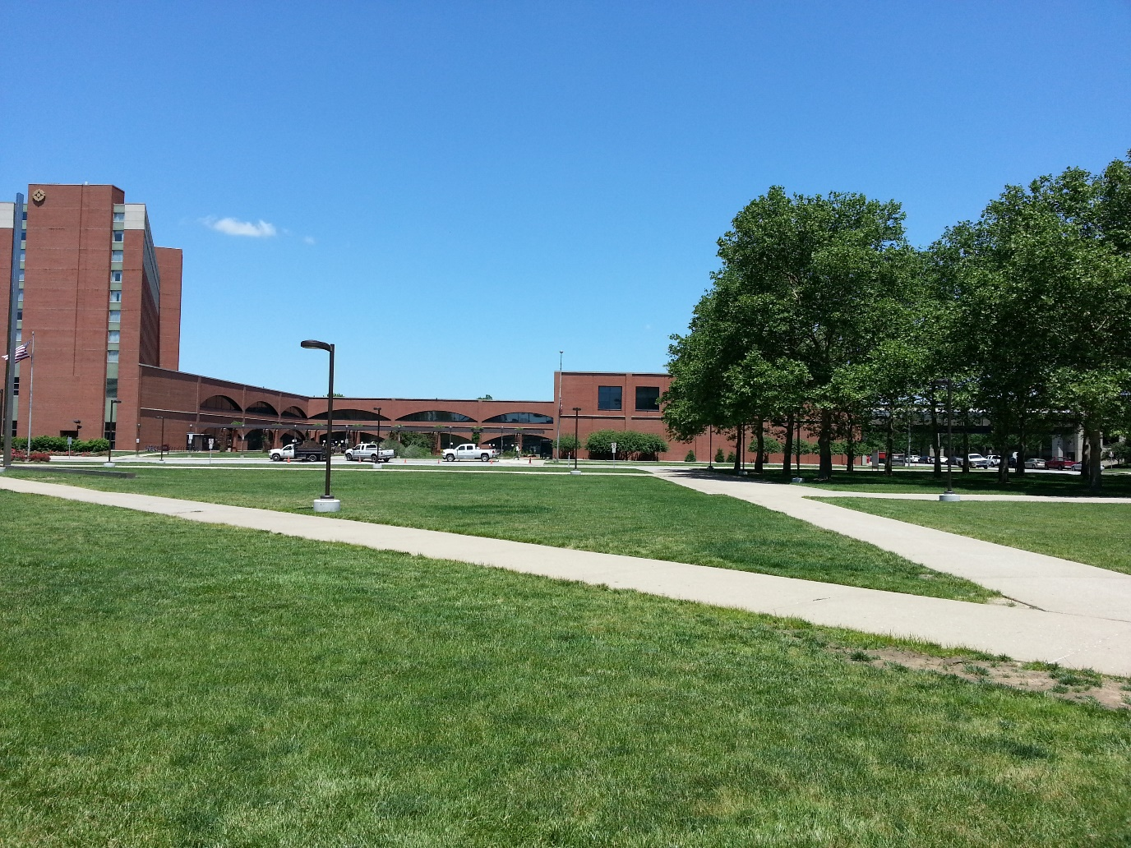

Figure Looking North from release area

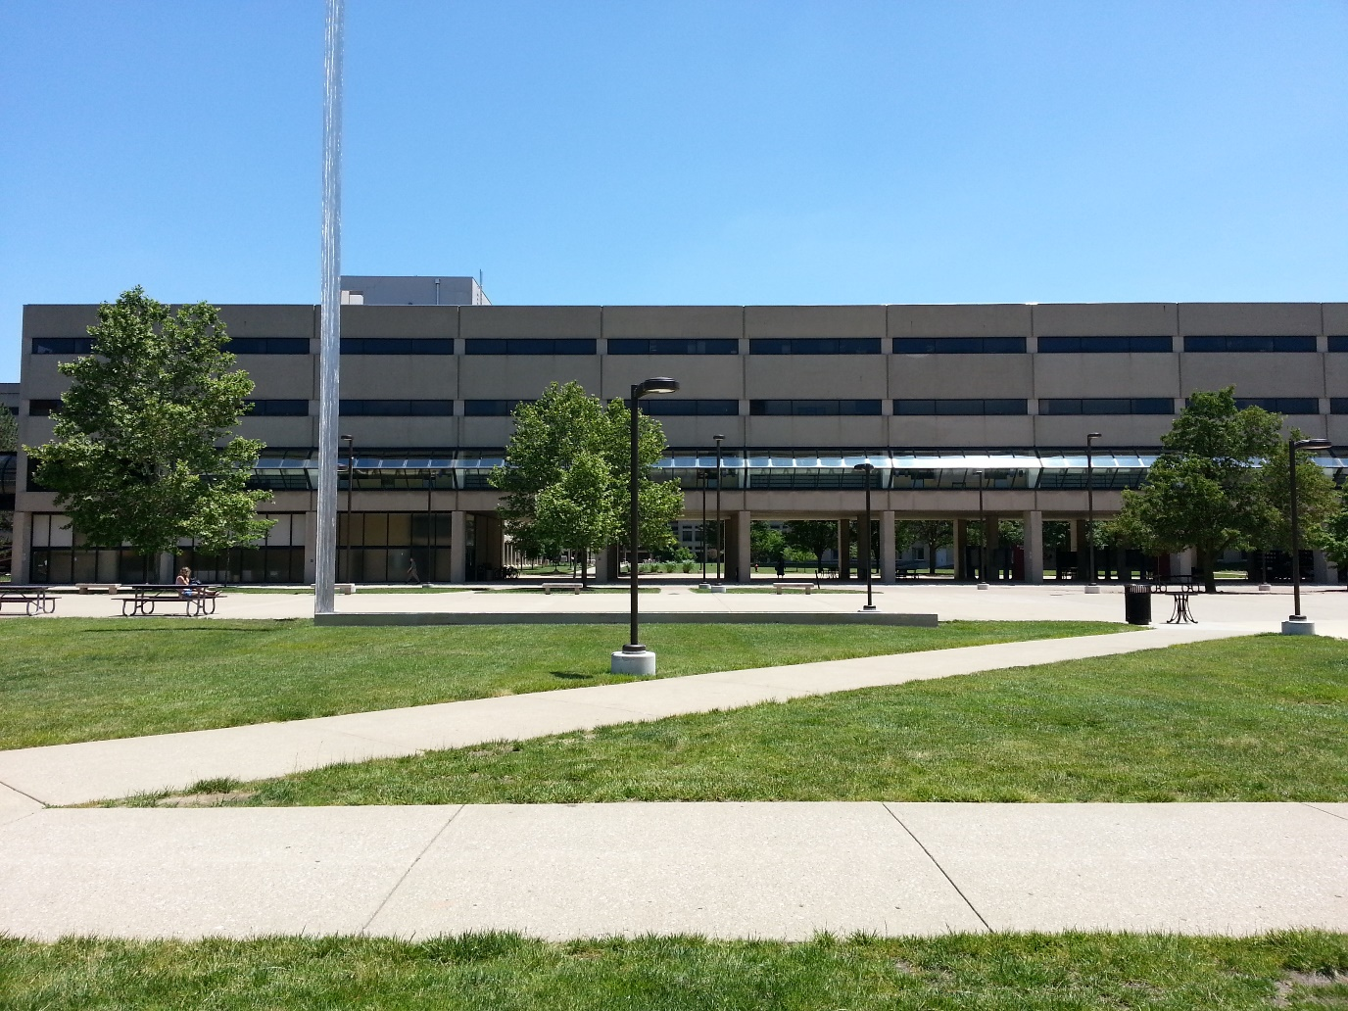

Figure Looking East from release area

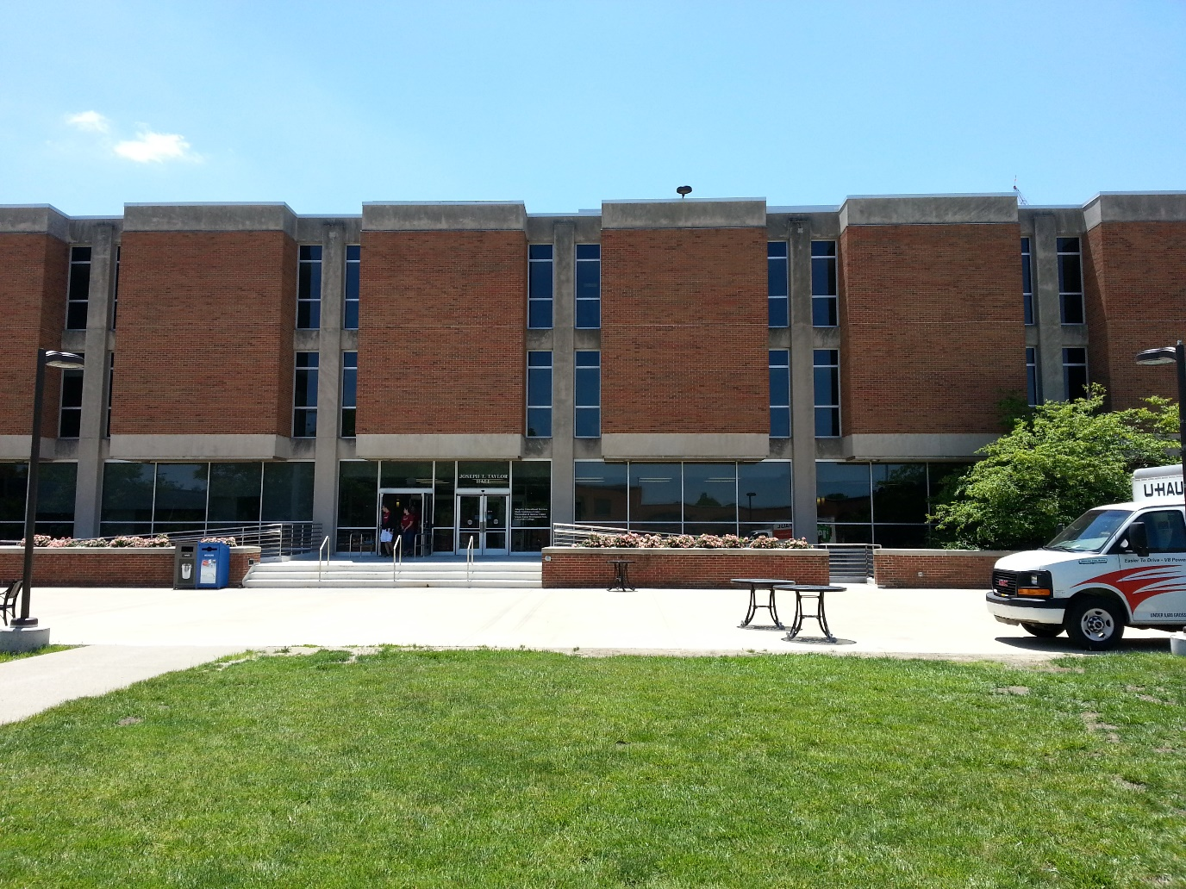

Figure Looking South from release area

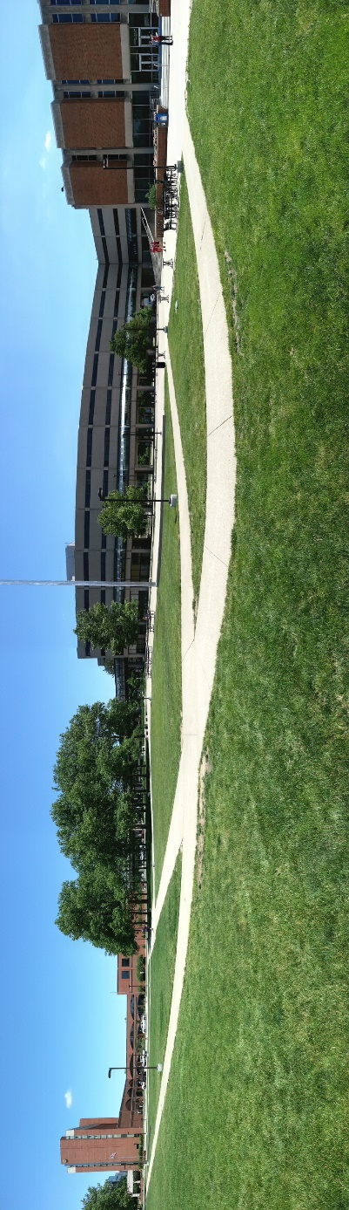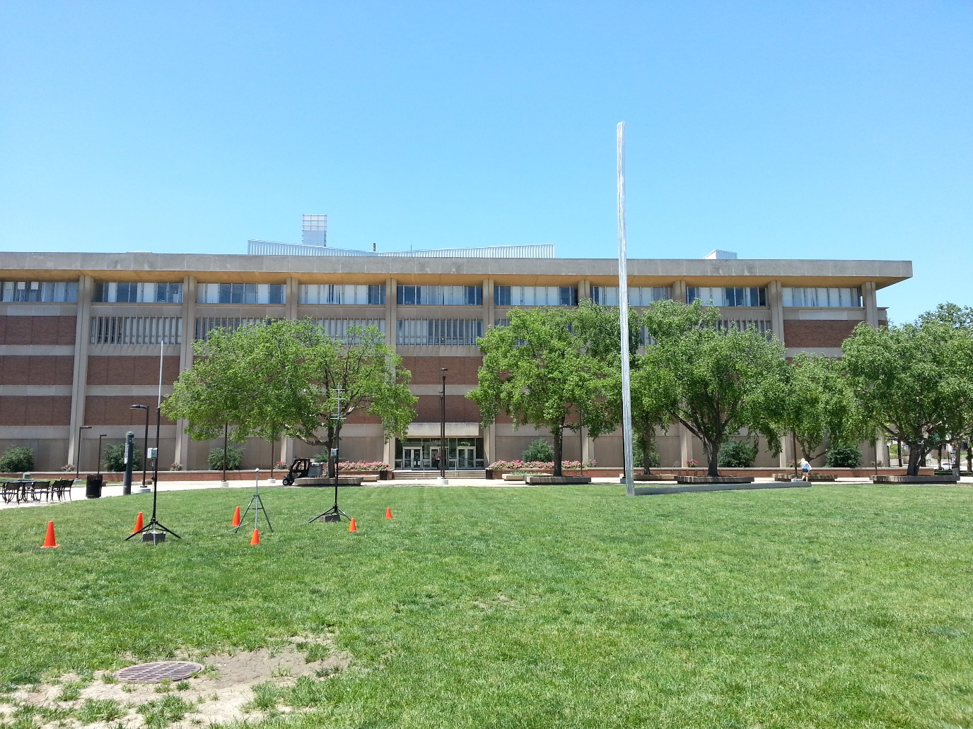

Figure Panoramic shot from North to South (Left to Right) from release area

Figure Looking West from release area

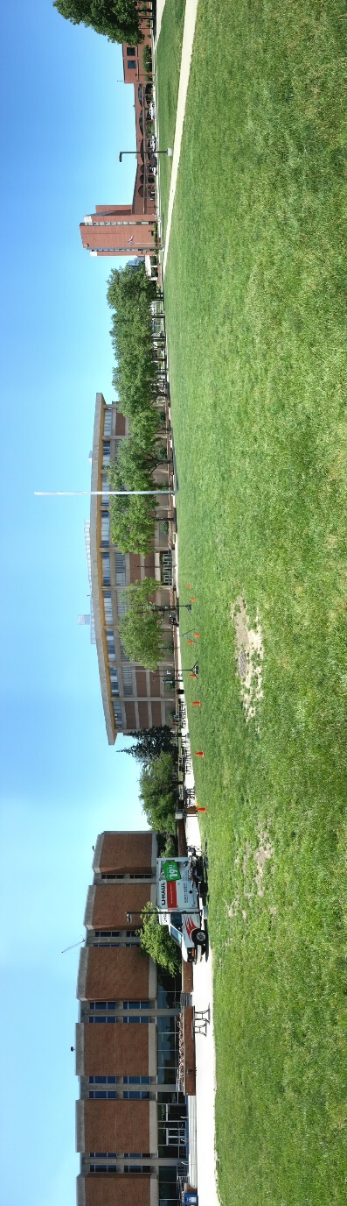

Figure Panoramic shot from South to North (Left to Right) from release area